**Institute of Technology Tralee**

**BSc. in Computing with Specialism (Group 3) - Year 1**

**Continuous Assessment #2**

**Date: 10/12/14**

**Time: 10a.m. – 12 p.m.**

**Introduction to Programming**

**Instructions:** Attempt the following question. You should use the JCreator IDE for coding. When you are finished you must print out your code for correction.

**________________________________________________________**

**Q1.**

A program is required that will read in an arbitrary number of country names, using a data-sentinel controlled **do-while** loop. The end of input will be signaled by the user entering “x” for the country name. The program will determine the following information based on the country names supplied:

* The number of country names entered
* The country with the shortest name
* The percentage of countries having between 10 and 15 characters inclusive (to 2 decimal places)
* The number of countries that begin with an uppercase ‘N’
* The list of countries that contain at least 2 ‘e’ characters (uppercase or lowercase) – **hint**: use a counter-controlled **while** loop for this part

Should the user enter no country names at all (i.e. just enter “x” immediately) then the program just issue a farewell message instead and not display any of the information above.

Using the test values as indicated in the screen shots below, the program should give you **exactly** the following output when it runs, including any banners, blank lines, tabs etc.

Also note that there will be a few marks awarded for having a **single-line comment** and **a meaningful multi-line comment at the top of the program**.

**Sample Screen Shots**

**Run 1 – The user enters several country names and the results get displayed**

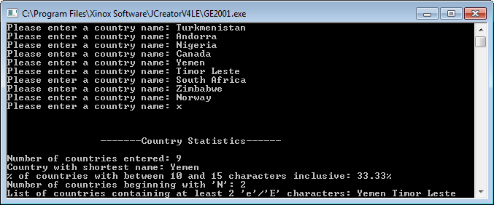

**Run 2 – The user enters “x” immediately so no results get displayed, just a farewell message**

